深圳市华商维泰显示科技有限公司
产 品 承 认 书
SPECIFICATION FOR APPROVAL
CUSTOMERMODEL NO.
WEITAI MODEL NO. | WTB068601G01-12M-IPS
TYPE | BOE6.86" IPS 480*(RGB)1280  配9706

■

WEITAI |  |  | CUSTOMER
PREPARED | CHECKED | APPROVED | APPROVED

深圳市华商维泰显示科技有限公司

地址：深圳市宝安区福永白石厦东区永泰东路8号利嘉发工业园B栋2楼

电话: 0755- 27367723
传真: 0755- 29563775

本规格承认书请确认签章后回传一份

深圳市华商维泰显示科技有限公司

DOCUMENT REVISION HISTORY
Version | DATE | DESCRIPTION | CHANGED BY
V00 | 2020.01.03 | New design

深圳市华商维泰显示科技有限公司
CONTENTS PAGE
- Features & Mechanical specifications 1
- Dimensional Outline 2
- Block Diagram 3
- Pin Description 4
- Absolute Maximum Ratings 5
- Electrical Characteristics 5
- Backlight Specification 5
- Electro-Optical Characteristics 6~7
- Instruction Description 8
- AC Characteristics 8
- Quality Specification 9~17
深圳市华商维泰显示科技有限公司
- Features & Mechanical Specifications
Item | Contents | Unit
Item | LCD | Unit
LCD Type | TFT Transmissive Normal Black | --
Viewing direction | ALL.O'CLOCK | --
Backlight | White LED x12in Parallel/ Series | --
Interface | MIPI | --
Driver IC | INC9706 | --
Outline Dimension | 66.6*181.0*4.6 | mm
Glass area (W×H×T) | 63.42*169.09*1.0 | mm
Active area (W×H) | 60.22*160.59 | mm
Number of Dots | 480*1280 | --
Pixel pitch (W×H) | 34.5*103.5 | um
Operating Temperature | -20 ～ +70 | ℃
Storage temperature | -30 ～ +80 | ℃
1
深圳市华商维泰显示科技有限公司
- Dimensional Outline
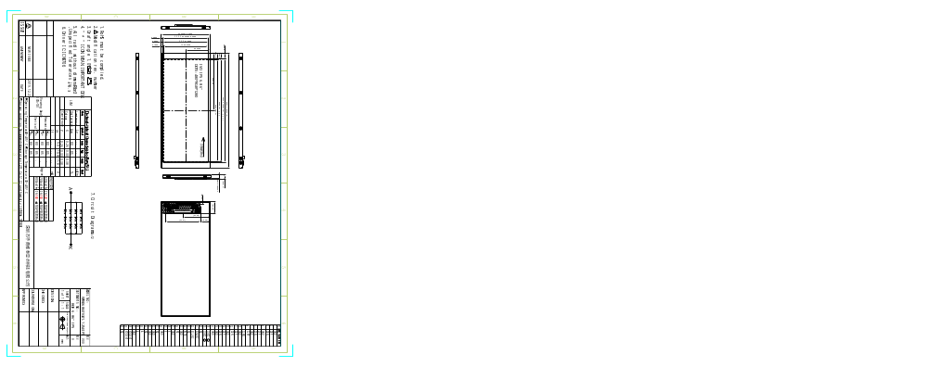

40
由此插入

黑色单面胶

周边黑色单面包边胶

深圳市华商维泰显示科技有限公司
- Block Diagram
深圳市华商维泰显示科技有限公司
- Pin Description
PIN No. | SYMBOL | Function
1 | GND | Ground
2 | DSI-D0P | DSI Data differential signal input pins. (Data lane0)
3 | DSI-D0N | DSI Data differential signal input pins. (Data lane 0)
4 | GND | Ground
5 | DSI-D1P | DSI Data differential signal input pins. (Data lane 1)
6 | DSI-D1N | DSI Data differential signal input pins. (Data lane 1)
7 | GND | Ground
8 | DSI-CLK P | DSI CLOCK differential signal input pins
9 | DSI-CLK N | DSI CLOCK differential signal input pins
10 | GND | Ground
11 | DSI-D2P | DSI Data differential signal input pins. (Data lane 2)
12 | DSI-D2N | DSI Data differential signal input pins. (Data lane 2)
13 | GND | Ground
14 | DSI-D3P | DSI Data differential signal input pins. (Data lane 2)
15 | DSI-D3N | DSI Data differential signal input pins. (Data lane 2)
16,17 | GND | Ground
18,19 | IOVCC | Power supply(1.8V)
20-23 | NC | NC
24 | RESET | Reset Signal pin (“Low” is enable)
25 | GND | Ground
26 | NC | NC
27 | GND | Ground
28,29 | LEDK | Backlight LED Cathode
30 | GND | Ground
31 | NC | NC
32,33 | GND | Ground

深圳市华商维泰显示科技有限公司
34 | NC | NC
35,36 | LEDA | Backlight LED Anode.
37 | GND | Ground
38,39 | VCC | Power supply(2.8V-3.3V)
40 | NC | NC
- Absolute Maximum Ratings
Item | Symbol | Rating |  |  | Unit
Item | Symbol | MIN. | TYP. | MAX | Unit
Supply Voltage range | VDD | -0.3 | - | VDD+0.3 | V
Power supply for gate drive | VGH |  | 15.0 |  | V
Power supply for gate drive | VGL |  | -8.0 |  | V
TFT Common Voltage | VcomH | 2.5 | - | 4.0 | V
TFT Common Voltage | VcomL | -2.0 | - | 0 | V
Operating Temperature range | TOP | -20 | - | +70 | ℃
Storage Temperature range | TST | -30 | - | +80 | ℃

- Electrical Characteristics
DC Characteristics
Item | Symbol | Min. | Type. | Max. | Unit
Logic Supply Voltage | VDD |  | 2.8- | 3.3 | V
I/O Supply Voltage | IOVCC | 1.65 | 1.8- | 3.0 | V

深圳市华商维泰显示科技有限公司

- Backlight Characteristics
White LED ×12 in Parallel/ Series (Ta = 25°C)
Item | Symbol | Condition | Min | Typ | Max | Unit
Forward Voltage | VF | IF=--mA | - | -- | - | V
Uniformity | △Bp | - | 80 | - | - | %
Luminance for LCD | Lv | IF=--mA | -- | - | - | cd/m2
深圳市华商维泰显示科技有限公司
- Electro-Optical Characteristics
Using LC+ Normal Polarizer+Corresponding Backlight, reference only (Note 1,Note 2)
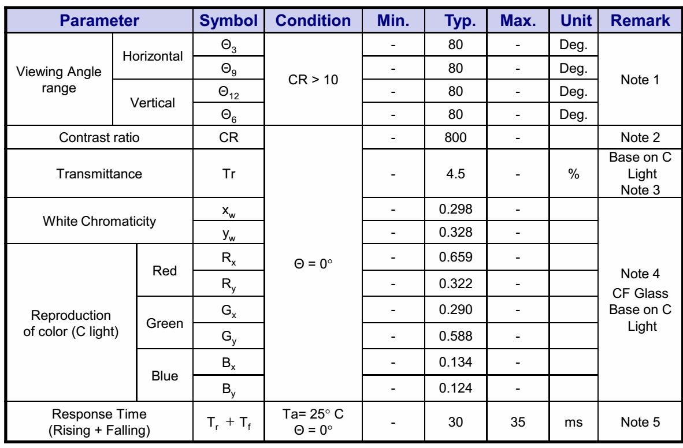
深圳市华商维泰显示科技有限公司
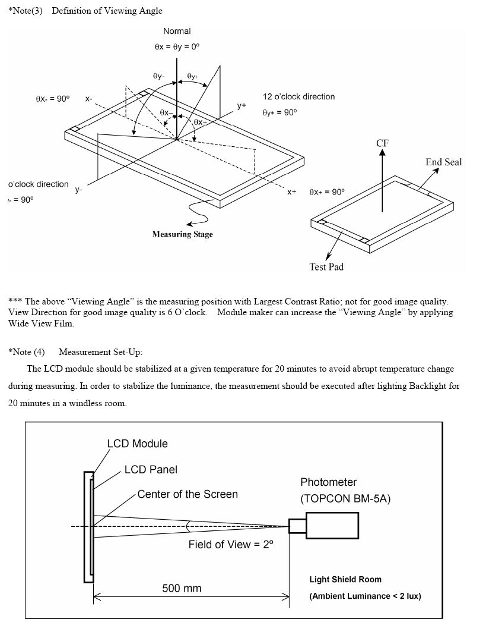
深圳市华商维泰显示科技有限公司
- Instruction Description
Please refer to ICN9706
- AC Characteristics
MIPI DSI Timing Characteristics HIGH SPEED MODE
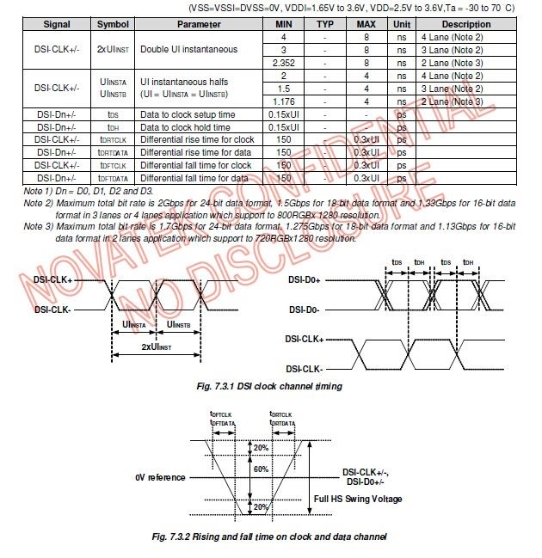
深圳市华商维泰显示科技有限公司
11.Quality Specifications
All The raw material are Rohs complicant.
11.1 Standard of the product appearance test
Manner of appearance test: The inspection should be performed in using 20W x 2 fluorescent lamps.
Distance between LCM and fluorescent lamps should be 100 cm or more. Distance between LCM and inspector eyes should be 30 cm or more.
Viewing direction for inspection is 45°from vertical against LCM.
Fluorescent Lamps


30cm min
100cm min
45o 45o
LCM
Definition of zone:
A Zone
B Zone
A Zone: viewing area
B Zone: outside viewing area

深圳市华商维泰显示科技有限公司
11.2 Specification of quality assurance
AQL inspection standard
Sampling method: MIL-STD-105E, Level II, single sampling
Defect classification (Note: * is not including)
Classify | Item |  | Note | AQL
Major | Display state | Short or open circuit | 1 | 0.65
Major | Display state | LC leakage | 1 | 0.65
Major | Display state | Flickering | 1 | 0.65
Major | Display state | No display | 1 | 0.65
Major | Display state | Wrong viewing direction | 1 | 0.65
Major | Display state | Contrast defect (dim, ghost) | 2 | 0.65
Major | Display state | Back-light | 1,8 | 0.65
Major | Non-display | Flat cable or pin reverse | 10 | 0.65
Major | Non-display | Wrong or missing component | 11 | 0.65
Minor | Display state | Background color deviation | 2 | 1.0
Minor | Display state | Black spot and dust | 3 | 1.0
Minor | Display state | Line defect, Scratch | 4  5 | 1.0
Minor | Display state | Rainbow | 4  5 | 1.0
Minor | Display state | Chip | 6 | 1.0
Minor | Display state | Pin hole | 7 | 1.0
Minor | Polarizer | Protruded | 12 | 1.0
Minor | Polarizer | Bubble and foreign material | 3 | 1.0
Minor | Soldering | Poor connection | 9 | 1.0
Minor | Wire | Poor connection | 10 | 1.0
Minor | TAB | Position, Bonding strength | 13 | 1.0
深圳市华商维泰显示科技有限公司
Note on defect classification
No. | Item | Criterion
1 | Short or open circuit | Not allow
1 | LC leakage | Not allow
1 | Flickering | Not allow
1 | No display | Not allow
1 | Wrong viewing direction | Not allow
1 | Wrong Back-light | Not allow
2 | Contrast defect | Refer to approval sample
2 | Background color deviation | Refer to approval sample
3 | Point defect,  Black spot, dust  (including Polarizer)  φ = (X+Y)/2 | Y  X  Unit：mm
4 | Line defect,  Scratch | W  L  Unit: mm
5 | Rainbow | Not more than two color changes across the viewing area.
Point  Size | Acceptable Qty.
φ<0.10 | Disregard
0.10<φ≤0.20 | 2（距离大于  5mm）
0.20<φ≤0.25 | 1
φ>0.25 | 0

Line |  | Acceptable Qty.
L | W
--- | 0.015≥W | Disregard
3.0≥L | 0.03≥W
- ≥L | - 5≥W
1.0≥L | 0.1＞W
--- | 0.05<W | Applied as point defect

No | Item | Criterion

深圳市华商维泰显示科技有限公司
6 Chip
Remark:
X: Length direction
Y: Short
direction


Z
X
Y
t
Acceptable criterion
X | Y | Z
≤2 | 0.5mm | ≤t/2

Z: Thickness

direction X Y
t: Glass
thickness
Acceptable criterion
X | Y | Z
≤2 | 0.5mm | ≤t

W: Terminal
Width
Z

Acceptable criterion
Y
X | Y | Z
≤3 | ≤2 | ≤t
shall not reach to ITO |  | ≤t

X
W
X
X
Y
Y
Z
Z
Acceptable criterion
X | Y | Z
Disregard | ≤0.2 | ≤t
Acceptable criterion
X | Y | Z
≤5 | ≤2 | ≤t/3

No. | Item | Criterion
7 | Segment | (1) Pin hole

X


X
Point Size Acceptable Qty
深圳市华商维泰显示科技有限公司
 | pattern  W = Segment width  φ = (X+Y)/2 | φ < 0.10mm is acceptable.
8 | Back-light | - The color of backlight should correspond its specification.  - Not allow flickering
9 | Soldering | - Not allow heavy dirty and solder ball on PCB.  (The size of dirty refer to point and dust defect)  - Over 50% of lead should be soldered on Land.  Lead  Land  50% lead
10 | Wire | - Copper wire should not be rusted  - Not allow crack on copper wire connection.  - Not allow reversing the position of the flat cable.  - Not allow exposed copper wire inside the flat cable.
11* | PCB | - Not allow screw rust or damage.  - Not allow missing or wrong putting of component.
No Item Criterion
12 Protruded
W: Terminal Width
W
- X
Y
Acceptable criteria:
Y ≤ 0.4
深圳市华商维泰显示科技有限公司

13 | TAB | 1. Position | H | W | W1 |  | ITO W1≤1/3W  H1≤1/3H  FPC
13 | TAB | 1. Position | H1 TAB |  |  |  | ITO W1≤1/3W  H1≤1/3H  FPC
13 | TAB | 2 FPC bonding strength test |  |  |  | F | ITO W1≤1/3W  H1≤1/3H  FPC
13 | TAB | P (=F/FPC bonding width) ≥650gf/cm ,(speed rate: 1mm/min)  5pcs per SOA (shipment)
14 | Total no. of acceptable Defect | N. Zone  Maximum 2 minor non-conformities per one unit.  Defect distance: each point to be separated over 10mm  B. Zone  It is acceptable when it is no trouble for quality and assembly in customer’s end product.
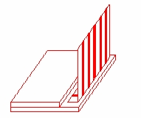
11.3 Reliability of LCM
Reliability test condition:
t
Item | Condition | Time (hrs) | Assessment
High temp. Storage | 80°C | 48 | No abnormali ies
High temp. Operating | 70°C | 48 | No abnormali ies

深圳市华商维泰显示科技有限公司

Low temp. Storage | -30°C | 48
Low temp. Operating | -20°C | 48
Humidity | 60°C/ 90%RH | 48
Temp. Cycle | -30°C ← 25°C →80°C  (60 min ← 5 min → 60min) | 10cycles
Recovery time should be 24 hours minimum. Moreover, functions, performance and appearance shall be free from remarkable deterioration within 50,000 hours under ordinary operating and storage conditions room temperature (20+8°C), normal humidity (below 65% RH), and in the area not exposed to direct sun light.
深圳市华商维泰显示科技有限公司
11.4 Precaution for using LCD/LCM
LCD/LCM is assembled and adjusted with a high degree of precision. Do not attempt to make any alteration or modification. The followings should be noted.
General Precautions:
- LCD panel is made of glass. Avoid excessive mechanical shock or applying strong pressure onto the surface of display area.
- The polarizer used on the display surface is easily scratched and damaged. Extreme care should be
taken when handling. To clean dust or dirt off the display surface, wipe gently with cotton, or other soft material soaked with isoproply alcohol, ethyl alcohol or trichlorotriflorothane, do not use water, ketone or aromatics and never scrub hard.
- Do not tamper in any way with the tabs on the metal frame.
- Do not made any modification on the PCB without consulting SUNYEE.
- When mounting a LCM, make sure that the PCB is not under any stress such as bending or twisting. Elastomer contacts are very delicate and missing pixels could result from slight dislocation of any of the elements.
- Avoid pressing on the metal bezel, otherwise the elastomer connector could be deformed and lose
contact, resulting in missing pixels and also cause rainbow on the display.
- Be careful not to touch or swallow liquid crystal that might leak from a damaged cell. Any liquid crystal adheres to skin or clothes, wash it off immediately with soap and water.
Static Electricity Precautions:
V. CMOS-LSI is used for the module circuit; therefore operators should be grounded whenever he/she comes into contact with the module.
W. Do not touch any of the conductive parts such as the LSI pads; the copper leads on the PCB
and the interface terminals with any parts of the human body.
- Do not touch the connection terminals of the display with bare hand; it will cause disconnection or defective insulation of terminals.
- The modules should be kept in anti-static bags or other containers resistant to static for storage.
Z.Only properly grounded soldering irons should be used.
AA. If an electric screwdriver is used, it should be grounded and shielded to prevent sparks.
BB. The normal static prevention measures should be observed for work clothes and working
benches.
CC. Since dry air is inductive to static, a relative humidity of 50-60% is recommended.

深圳市华商维泰显示科技有限公司
Soldering Precautions:
DD.Soldering should be performed only on the I/O terminals.
EE. Use soldering irons with proper grounding and no leakage.
FF.Soldering temperature: 280°C+10°C
- Soldering time: 3 to 4 second.
- Use eutectic solder with resin flux filling.
- If flux is used, the LCD surface should be protected to avoid spattering flux.
- Flux residue should be removed.
Operation Precautions:
KK. The viewing angle can be adjusted by varying the LCD driving voltage Vo.
LL. Since applied DC voltage causes electro-chemical reactions, which deteriorate the display, the
applied pulse waveform should be a symmetric waveform such that no DC component remains. Be sure to use the specified operating voltage.
MM. Driving voltage should be kept within specified range; excess voltage will shorten display life.
- Response time increases with decrease in temperature.
- Display color may be affected at temperatures above its operational range.
- Keep the temperature within the specified range usage and storage. Excessive temperature and humidity could cause polarization degradation, polarizer peel-off or generate bubbles.
- For long-term storage over 40°C is required, the relative humidity should be kept below 60%,
and avoid direct sunlight.
Limited Warranty
SUNYEE LCDs and modules are not consumer products, but may be incorporated by SUNYEE’s customers into consumer products or components thereof, SUNYEE does not warrant that its LCDs and components are fit for any such particular purpose.
PP. The liability of SUNYEE is limited to repair or replacement on the terms set forth below.
SUNYEE will not be responsible for any subsequent or consequential events or injury or damage to any personnel or user including third party personnel and/or user. Unless otherwise agreed in writing between SUNYEE and the customer, SUNYEE will only replace or repair any of its LCD which is found defective electrically or visually when inspected in accordance with SUNYEE general LCD inspection standard. (Copies available on request)
QQ. No warranty can be granted if any of the precautions state in handling liquid crystal display
above has been disregarded. Broken glass, scratches on polarizer mechanical damages as well as defects that are caused accelerated environment tests are excluded from warranty.
RR. In returning the LCD/LCM, they must be properly packaged; there should be detailed
description of the failures or defect.

